**Browser Object Model (BOM)**

The Browser Object Model contains objects that represent the current browser window or tab. The topmost object in the BOM is the ***window*** object representing the window or tab or an iframe sometimes. Window object has properties like browser history, location and the device’s screen etc. In case of multi tab browser, *a window object represents a single tab*, but some of its properties like *innerHeight*, *innerWidth*and methods like *resizeTo()* will affect the whole browser window.

## **Document Object Model**

When a web page is loaded, the browser creates a Document Object Model of the page. The *document object* represents the whole html document as a tree of Objects(HTML, HEAD, BODY, and other HTML tags). It is the root element that represents the html document.

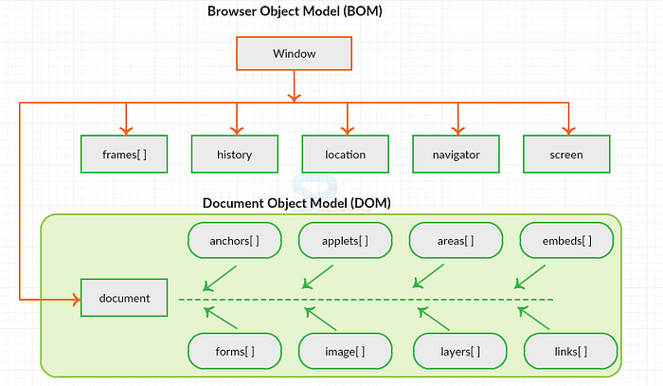

**Codekata; https://www.guvi.in/code-kata-main?concept=Input/Output**